Group 2 Software Project Management Plan

- Revision History

Date | Updated By | Comment
10/10/2017 | K. Franklin, J. Ray, G. Akanni, F. Daneshpour, B. Cavender, P. Carpenter | Initial SPMP creation
10/18/2017 | F. Daneshpour, G. Akanni | First SPMP revision
10/26/17 | G. Akanni F. Daneshpour, | SPMP revision
11/25/17 | K. Franklin | Incorporated requirements change

- Table of Contents
Part 1 ………………………………………………………………………………………..……3
1.1 Project Overview
1.2 Project Deliverables
1.3 Evolution of the SPMP
1.4 Reference Materials
1.5 Definitions and Acronyms

Part 2 …………………………………………………………………………………………… 3
2.1 Organizational Structure
2.2 Organizational Interfaces
2.3 Project Responsibilities

Part 3 …………………………………………………………………………………………….4
3.1 Management Objectives and Priorities
3.2 Assumptions, Dependencies, and Constraints
3.3 Risk Management
3.4 Monitoring and Controlling Mechanisms

Part 4 ……………………………………………………………………………….…………….5
4.1 Methods, Tools, and Techniques

Part 5 ……………………………………………………………………………………………..6
5.1 Work Breakdown Structure

Part 1

1.1 Project Overview

This website will provide information to teenagers about health and fitness regarding their selected sport. This will be partnered with a fun and interactive game where the teenagers can explore more about health and fitness. Athletic coaches can access player’s profiles to monitor their progress. Teenagers will also be able to access directories with information about contacting different health and fitness experts. Sponsors will be able to make donations to the program through the site, and featured sponsors will be displayed for all users to see.

1.2 Project Deliverables

- Requirements
- Use Case, Sequence Diagrams
- HLA, Class Diagram, Interface Spec
- GitHub Repository
- Code

1.3 Evolution of the SPMP

- Client changes requirements.
- Any sort of budget change.

1.4 Reference Materials

SPMP Template:
http://www.utdallas.edu/~chung/CS6354/CS6354_U07_source/Team_2/Software_Project_Management_Plan_v1.1.doc

1.5 Definitions and Acronyms

HLA - High Level Architecture
SPMP - Software Project Management Plan

Part 2

2.1 Organizational Structure
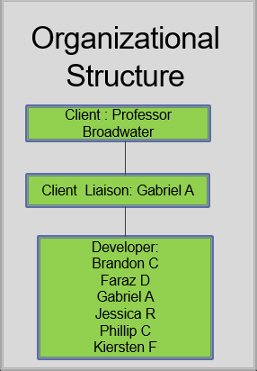

2.2 Organizational Interfaces

- Payment Processor
- Google Location Services
- Website Domain/Server
- Various Social Media Services

2.3 Project Responsibilities

The entire team is responsible for delivering the project.

Part 3

3.1 Management Objectives and Priorities

Main priorities are to make sure the site is stable and runs without crashing, the game environment is intriguing and bug-free, sponsors are able to make donations to the program, and the subscription service stays running at all times.

3.2 Assumptions, Dependencies, and Constraints

- Assumptions
  - Team of 6 group members.
  - Website domain availability.
- Dependencies
  - Staff to have a general knowledge of health and safety information as the game development revolves around this.
  - Variety of professionals to add services to the site
- Constraints
  - Time until project is due.
  - Time available for each member to work on project.

3.3 Risk Management

- Technology Risk - Server and or site crashing, data breaches
- People - Version control issues
- Structure/Process Risks - Too much flexibility

3.4 Monitoring and Controlling Mechanisms

- GitHub repository
- Weekly team meetings

Part 4

4.1 Methods, Tools, and Techniques

The project will be implemented utilizing agile methodology, and tools such as IDE, text editor, SQL server, text editor, and GitHub.

Part 5
